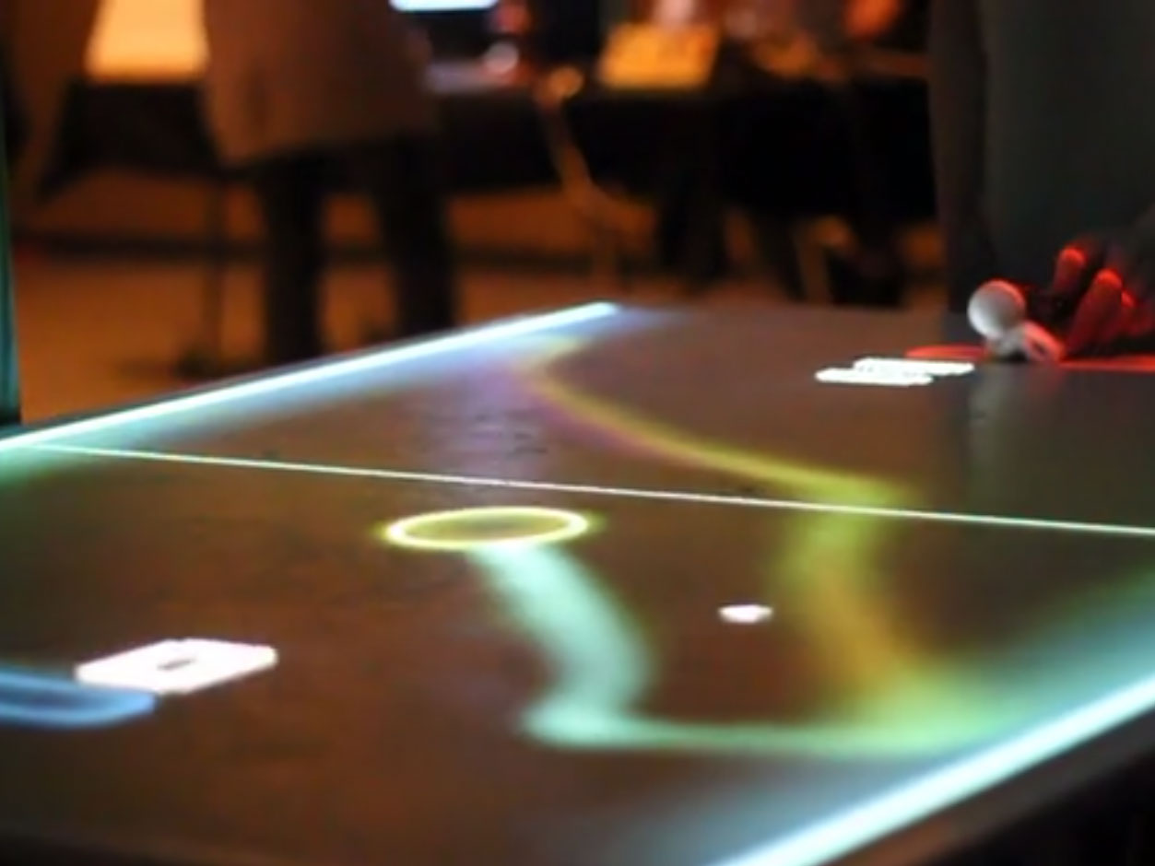

Preliminary Report

Augmented reality game board

Mark Maizles | 3128312132

Idan Sheffer | 321321321

Amit Zeligman | 321321321  
Vlad Winter | 312831787

361.1.4751 | Introduction to Digital Image Processing | 28.12.2017

# Abstract

The Augmented Reality Game Board is a platform consists of software and hardware which allows one or more players to play a game and interact with it in various ways. The game is being projected on the table, the players hands are being identified and tracked by a camera and image processing. The proposed games to implement are: Pong, Hockey Table, Tetris, and even a simple Painter app.

# System Description

The system is composed of both hardware and software.

## The Hardware:

* **Flat Table** – or any flat surface that can be projected on.
* **Projector** - will be installed above the table, held by some rig, pointing downwards.
* **Camera** – webcam or any other camera that can be connected to a computer, also held above the table and pointing downwards.
* **Computer** – connects the input (camera), does the processing and outputs (projector).
* **Others** – A rig or a frame to hold the camera and projector.

## The Software:

The software will consist of 2 main parts:

* **Input Processing** – The real-time image captured by the camera will need to be processed for a few purposes:
  + Detect and track players’ hands locations.
  + Calculate the players’ hands movement vector – speed and direction.
  + Detect the tables’ boundaries.
  + Detect other items – possibly labeled or marked – that will incorporate into the game in some manner.
* **Game Engine** – that will run the game itself, receiving inputs from the processed camera images of the board.

# Aims

* **Real Time Processing** – Our algorithm must be fast enough to deal with real time game speed. We will determine later the exact speed the algorithm should handle with.
* **Accurate hand detection and movement estimation –** We aim the algorithm to be Robust such that any hand movement that we consider as a part of the game will be properly detect and estimate accurately.
* As a result of the above states, our main goal is to derive hands on system, that will supply the user full game envelope with real time response under the following assumptions.

# Assumptions

* **Light Conditions** – We assume that the environment will be dark enough for the projector to project a clear and bright image, that will not interfere with the image processing by the camera – specifically of identifying the location of the hands and table boundaries.
* **Table Background** – We consider the table to be clean white, with no interruptions of strange elements, besides the players hands and the dedicated objects we will consider as part of the game.
* **Camera Perspective** - The Image detection camera will be pre-calibrate, such that the perspective will be totally flat with the table plan.
* **Base pong algorithm** – Our project is about image processing. Consequently, we are not going to focus on the game base software implementation and we will use exist IP's to derive it.

# Algorithms Overview

Like stated previously, we will need to use algorithms that will do the following tasks:

**Surface/Table Boundaries Detection [Pre-processing] –**

Canny + Hough Lines + Find corners out of the lines.

**Hands Detection and Tracking –**

Detection based on Skin Color

Detection based on Convexity [5]

**Hands Movement Vector Estimation –**

Based on Kalman filter.

**Various Hands Gesture Detection –**

Further research required.

# References

1. **An implementation of a Pong game with similar principles:**
   * <http://jason-webb.info/2011/07/tabletop-augmented-reality-pong-game/>
2. **Face Real Time Detection:**
   * <https://www.beyond-reality-face.com/overview>
3. **Hand tracking and gesture recognition system for human-computer interaction using low-cost hardware**
   * <https://link.springer.com/article/10.1007/s11042-013-1501-1>
4. <http://www.robots.ox.ac.uk/~vgg/research/hands/>
5. **Hand Tracking in OpenCV** 
   * <https://sanjayslnarayanan.files.wordpress.com/2013/08/handtrackingopencv.pdf>
6. <https://www.intorobotics.com/9-opencv-tutorials-hand-gesture-detection-recognition/>